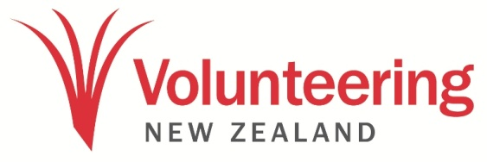

Promo copies

2022 IV Day promotional copy for social media and websites

International Volunteer Day 2022 – 50 words
International Volunteer Day, on 5 December 2022, has the theme solidarity through volunteering. For the future of our planet, we must act together and we must act now. This is not an era to stand alone but together, as one, in solidarity with each other. On 5 December, let’s join with all volunteers across the globe to recognise the power of volunteering.

International Volunteer Day 2022 – 100 words
International Volunteer Day, on 5 December 2022, has the theme solidarity through volunteering. For the future of our planet, we must act together and we must act now. This is not an era to stand alone but together, as one, in solidarity with each other. On 5 December, let’s join with all volunteers across the globe to recognise the power of volunteering.

Volunteering is where compassion meets solidarity. Both share the same core values – supporting each other from a position of trust, humility, respect and equality.

In the lead up to #IVDAY2022, join us to celebrate the spirit of volunteerism. We are proud of all volunteers who are role models in their communities and whose actions inspire hope.

International Volunteer Day 2022 – 200 words
International Volunteer Day, on 5 December 2022, has the theme solidarity through volunteering. For the future of our planet, we must act together and we must act now. This is not an era to stand alone but together, as one, in solidarity with each other. On 5 December, let’s join with all volunteers across the globe to recognise the power of volunteering.

Now is a great time to harness the energy of volunteering, adapting volunteering to a post-Covid world and seeking out diverse volunteer audiences. As the world and people’s lives change, so too must volunteering shift to fit within new ways of living, emerging priorities and values and ways of connecting.
Volunteering is at an all-time high in public and organisational consciousness and that volunteering gives us hope that we can change the world for the better.
The latest data from Statistics New Zealand shows that people who volunteered rated life as more worthwhile on average (8.1/10) than those who did not volunteer (7.9/10).
Among those who volunteered (50.7% of people over the age of 15), environmental volunteerism grew in popularity. The proportion of those who volunteered increased from 6.9 percent in 2016 to 11.1 percent in 2021.
In the lead up to #IVDAY2022, join us to celebrate the spirit of volunteerism. We are proud of all volunteers who are role models in their communities and whose actions inspire hope.

